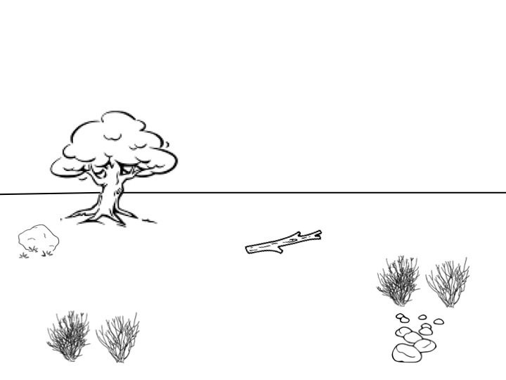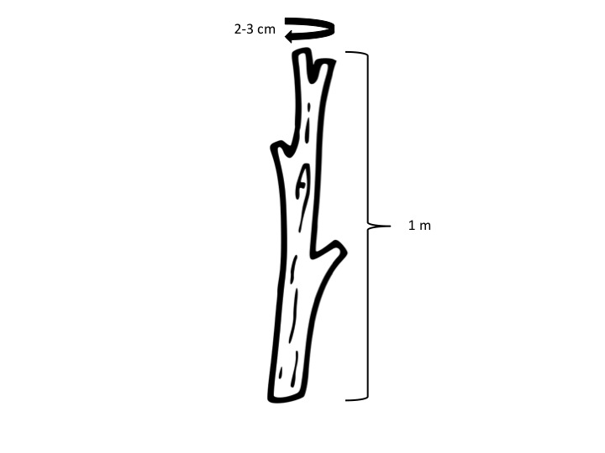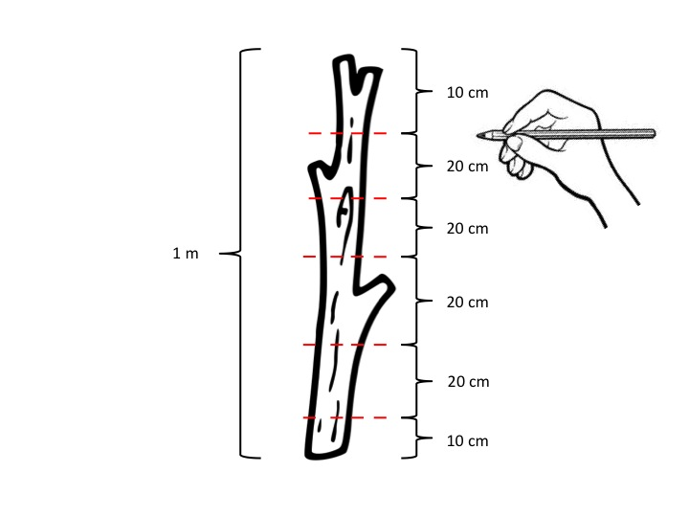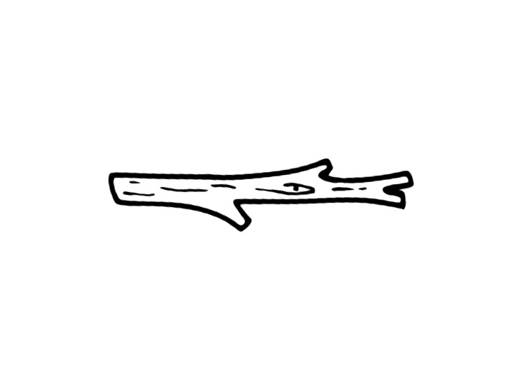

CUT TO: Close up of stick. Show person measuring out 1 m long, 2-3 cm in diameter.

Show an outdoor landscape. A silhouette of a person slowly fades in. He walks to the stick to pick it up.

CUT TO: Close up of stick. Each measurement fades in individually. The hand moves with each new line. Fade in 1 m measurement after. Fade out numbers to show the stick is ready to be used.

CUT TO: The stick slowly turns on its side. The image fades out. END.